

**Submitted To:**

**Er. Kamal Lekhak**

**Asst. Lecturer**

**FWU, School Of Engineering**

**Submitted By:**

**Lalit Bdr. Negi [26]**

**Dammara Thagunna [14]**

**Dhanesh Badal [15]**

**Sarswati Bhandari [40]**

**Bhuwan Sarki [11]**

**2080/06/04**

**Project Report**

**DIGITAL CLOCK**

**Table Of Content**

**1)Acknowledgement…………………………………………………………………………………….3**

**2)Introduction……………………………………………………………………………………………4-5**

**2.1)Introduction To Digital Clock…………………………………………………………….4**

**2.2)Objectives………………………………………………………………………………….…….4**

**2.3)Features……………………………………………………………………………………………5**

**2.4)Application Of Digital Clock…………………………………………………..………....5**

**3)Methodology…………………………………………………………………………………...6-13**

**3.1)Components…………………………………………………………………….………….6-11**

**3.2) Requirements……………………………………………………………….……………….11**

**3.3)Working Mechanism……………………………………………………………….……..12**

**3.4)System Design………………………………………………………………………………..13**

**4)Feasibility………………………………………………………………………………..………...13-13**

**4.1)Technical Feasibility……………………………………………………………………….13**

**4.2)Economical Feasibility……………………………………………………………..…….14**

**4.3)Output…………………………………………………………………………………………..14**

**5)Conclusion……………………………………………………………………………………………….15**

1. **Acknowledgement**

We would like to express our sincere gratitude to all those who have supported and helped us through the duration of this project. We would like to extend our special thanks to our project guide Er. Kamal Lekhak, who has provided us with valuable guidance, support, and feedback throughout the project.

Also, we would like to extend our heartfelt thanks to our friends for the collaboration which makes us easy to understand various aspects of the project.

Furthermore, we are grateful to our colleagues and peers for their collaborative efforts, discussions, and constructive feedback that significantly enhanced the quality and depth of this report.

This report would not have been possible without the collective efforts and support of every team member.

**2)Introduction**

**2.1 Introduction Of Digital Clock**

The digital clock is a widely used devices in our daily life. A digital clock is type of clock that displays the time in numeric. In the 21st century time being more than money, regarding this change our hobbies of checking our time every minute is dramatically increasing. About 99% of today’s digital clocks are made using microcontrollers which make them more hand able from the rest, those we can set the time to start any minute or second, we want and also set an alarm for reminder so that the system will store the value in a memory and then when the time reaches the alarm will be on.

These clocks have become ubiquitous in various settings, from homes and offices to public spaces and electronic devices.

**2.2 Objectives**

The main objectives are mentioned below:

* To build a digital clock and know the working principle of digital clock.
* To know about the each and every component and their working principles.
* To know about the connection of decoder and counters and other components on circuit.
* To understand into practice.

**2.3 Features**

A digital clock is a type of timekeeping device that displays the time using numerical digits rather than traditional analog hands. Here are some common features of digital clocks:

* Display time in digital format.
* Easy to understand the circuit and its working principle.
* It allows manual time to set up setting.­­
* We can set frequency for the entire circuit by function generator.
* Easy to create the circuit by less number of components.

**2.4 Application Of Digital Clock**

In today’s time, time is money. A digital clock displays the time used by numbers and keeps us updated. Digital clocks are used in different kinds of devices such as cars, mobile phones, microwave ovens, computers, and many other devices. some of the common applications are as follows:

* + - Timekeeping in homes and offices.
    - Stopwatches
    - Alarms and timers
    - Industrial control systems

**Digital clock**

**Stopwatch Alarm**

**3) Methodology**

**3.1 Components**

There are some components which are required to design a digital clock.

**1. Clock signal**

In digital clocks, the clock signal is a fundamental element that regulates the timing and sequencing of various operations within the clock's internal circuitry. The clock signal serves as a heartbeat for the digital components, ensuring that different parts of the clock synchronize and operate at the correct speed. The high level of the waveform can be different according to the requirement of the circuit.

In TTL standard it is 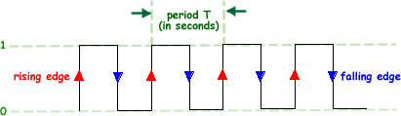5V.

**Fig. clock signal/pulse**

**2. Seven Segment BCD Display**

A Seven-Segment BCD (Binary-Coded Decimal) display is a type of electronic display used to represent decimal numbers using a combination of seven segments. This provides a very convenient way of displaying information or digital data in the form of numbers, letters or even alpha-numerical characters. The output from decoders is given to these units so they can display the output in the format that a person can understand. Each segment is either on or off, and when they are appropriately illuminated, they form numbers from 0 to 9. BCD is a way to represent each decimal digit with a binary code. Seven segment displays are of two types, common cathode, and common anode.

**Fig. seven segment BCD display**

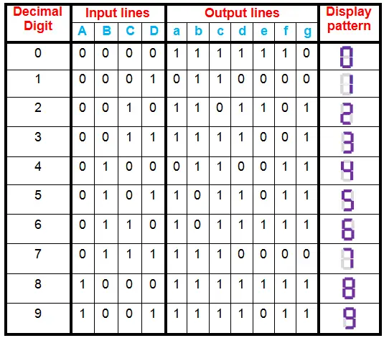**Truth Table:**

**Using k-map:**

|  |  |  |
| --- | --- | --- |
| **a= A+C+BD+B**′**D**′ | **b= B**′**+C**′**D**′**+CD** | **c= B+C**′**+D** |
| **d= B**′**D**′**+BC**′**D+B**′**C+CD**′**+A** | **e= B**′**D**′**+CD**′ | **f= C**′**D**′**+BC**′**+A+BD**′ |
| **g= A+BC**′**+B**′**C+CD**′ |  | |

**4. 7490 Decade Counter**

A counter is basically a system that advances each time a clock signal is given to it. Build with flip flops, a counter is probably one of the most useful and versatile subsystems in a digital system. We can "set it up" by changing the wiring of the R01, R02, R91 and R92 lines. If both R01 and R02 are 1 (5 volts) and either R91 or R92 are 0 (ground), then the chip will reset QA, QB, QC and QD to 0. If both R91 and R92 are 1 (5 volts), then the count on QA, QB, QC and QD goes to 1001(i.e., 9).

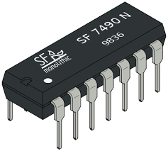These counters are used in digital clock to count the clock cycle and with the number of cycles changing uniformly with respect to the time it can be converted to its respective decimal number and be displayed.

**Fig. IC 7490N decade counter**

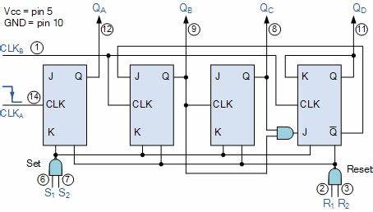

**Fig. BCD counter 74LS90N**

**5. AND Gate**

The AND gate is so named because, if 0 is called "false" and 1 is called "true," the gate acts in the same way as the logical "and" operator. The following illustration and table show the circuit symbol and logic combinations for an AND gate. (In the symbol, the input terminals are at left and the output terminal is at right.) The output is "true" when both inputs are "true." Otherwise, the output is "false." In other words, the output is 1 only when both inputs one AND two are 1.

**Fig. AND Gate**

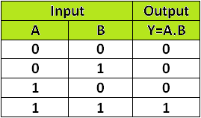**Truth Table:**

**6. SW SPDT Switch**

Switches are the most essential devices in an electric field. The main function of a switch is to open or close an electrical circuit. Generally, the electric circuits change from simple make or simply break circuits to multi make or multi-break circuits**.** A Single Pole Double Throw (SPDT) switch is a type of electrical switch that has three terminals and can be in one of two positions: either on or off. It is a common type of switch used in various electrical and electronic applications.

Simply this is used in digital clock to set time in 24- or 12-hour format and set the hour and minutes in custom.

**L1 & L2:** These two are the connections which are connected through output of AND gate and reset from the counter.

**Common (COM)**: The central terminal which is the point of connection shared by both throw positions.

**Fig. SW SPDT Switch**

**7. 1K Resistor**

A 1k resistor (1 kilohm resistor) in a digital clock circuit, like any resistor in an electronic circuit, could have several potential functions depending on the specific design and application. Resistors are commonly used in electronic circuits for various purposes, including current limiting, voltage division, pull-up or pull-down functions, timing, and signal conditioning.

**1.0k**

**Fig. 1k resistor**

**8. Power Source**

A power source is the device that provides electrical energy to a device or circuit. To create a digital clock circuit, power supply must be given to the circuit. Which will continue to timekeeping of the clock.

**3.2 Requirements**

To design the digital clock following things are needed.

**a. Software Requirements**

There are lots of software that allows us to design the circuit as per our requirements. For example, Logisim, multisim, proteus etc. we have used proteus to design the circuit of this project.

**b. Hardware Requirements**

Computer or laptop, 7490 dacade counter, seven segment display, AND gate, switch, wires, etc.

**3.3 Working Mechanism**

The working mechanism of digital clock depends on all the components that are used in the circuit. The main component which will run the circuit is the function generator which will provide the frequency to the counter. The clock pulse are fed into the decade counter IC, which counts the pulses and increments its count by one with each rising edge of the clock pulse.

The decade counter which counts from 1 to 10, we have the counter count only the binary numbers 0000 to 1001 i.e., from 0 to 9 in decimal. The output of the decade counter is connected to the seven-segment display, which displays the current time.

The seven-segment display is driven by the output of the decade counter IC, which is used to select which segment of the display should be lit up. The output of the decade counter is in binary code which will decoded and displayed by the seven-segment display. The digit showing of the seven-segment display is mentioned below as:

* **Digit 0:** Segments a, b, c, d, e, f are lit.
* **Digit 1:** Segments b, c are lit.
* **Digit 2:** Segments a, b, d, e, g are lit.
* **Digit 3:** Segments a, b, c, d, g are lit.
* **Digit 4:** Segments b, c, f, g are lit.
* **Digit 5:** Segments a, c, d, f, g are lit.
* **Digit 6:** Segments a, c, d, e, f, g are lit.
* **Digit 7:** Segments a, b, c are lit.
* **Digit 8:** All segments (a, b, c, d, e, f, g) are lit.
* **Digit 9:** Segments a, b, c, d, f, g are lit.

The SW SPDT switch is used to set the time format in 12- or 24-hour format. There are three SPDT switches one of them is used to set the time format in 12- or 24-hour format. The middle one is used to set the hour for our requirement time hour and last one is used to set the minute on our own requirement of the time which we want to set.

The 1N4007 Diode is used to flow the direction of the current from the right to left in only one direction.

**3.4 System Design:**

**Fig. complete circuit of digital clock**

**4) Feasibility**

Creating a digital clock project is certainly feasible and can be a fun and educational DIY electronics project. The feasibility depends on your level of experience, the resources you have, and the complexity of the digital clock you want to build. The purpose of a feasibility test is to determine whether the project or system is worth pursuing, based on a number of factors such as:

**4.1 Technical Feasibility:**

This involves evaluating the technical aspects of the project or system to determine if it is possible to build, given the available technology and resources. This project is technically feasible due to following reasons:

* The wide availability of components and tools.
* Easy to design and develop a digital clock.
* The use of digital logic gates and other basic electronic components can be used to create a simple digital clock circuit.

**4.2 Economical Feasibility:**

This involves evaluating the finical aspects of the project to determine if it is economically viable. This includes considering the cost of development, maintenance, and operation as well as any potential returns on investment. This project is economically feasible due to following reasons:

* The cost of the components and materials needed to produce a digital clock is relatively low.
* Since there is high demand for digital clock so ability to sell digital clock at a reasonable price will yield a profit.
* Advancement in technology has decreased the cost of production over the years.

**4.3 Output:**

The following are the general outcomes of the project:

1. A design that meets the desired aesthetic and usability requirements.
2. A cost-effective and reliable final product.
3. A functional digital clock that can accurately keep track of time and display it on a screen.
4. Good to understand the concept of components used and their working principle.

**5) Conclusion**

In conclusion, our project performed successfully shows the accurate time keeping function. Through all the time of this project we have learned how the components works and how the final circuit working principle. Through meticulous design and persistent troubleshooting, we overcame challenges, honed our problem-solving skills, and expanded our understanding of electronics. The user-friendly interface and accurate time display on usability and functionality. This project signifies our technical, ability to design the digital clock and its importance in our daily lives, teamwork and also emphasizes the innovative mind set. this project also defines what we can do if the different mindset and different ideas are combined together. As we reflect on our journey, we are confident that the skills and knowledge gained will propel us towards even more ambitious technological endeavors in the future.